Did you know?

In NSW, you can be fined over $1000 if you release more than 20 gas-filled balloons.

In the NT, you can be fined $200 if you are a musician or busker who ‘play musical instruments so as to annoy’.
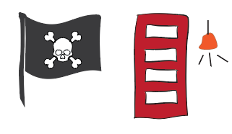
In Victoria, it is illegal to do business with pirates. If you do, you could go to prison for up to 10 years!
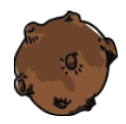
In Tasmania, taking or possessing a meteorite is worth a fine of nearly $1600.
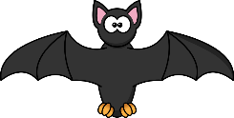
In WA, you could spend up to a year in jail for cleaning up bat poo!
In SA, you could be fined up to $250 if you ring someone’s doorbell without good reason!
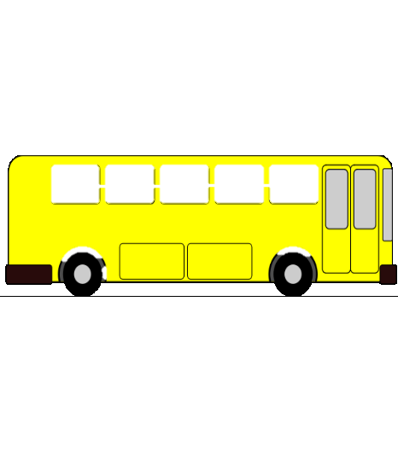

In QLD, you can not take your pig, goat or cow onto public transport.
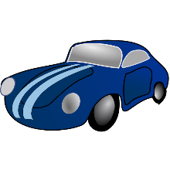
In the ACT, you can be fined if you beep your horn when saying hello or goodbye to your friends.

