Visit your local government website to help your research.

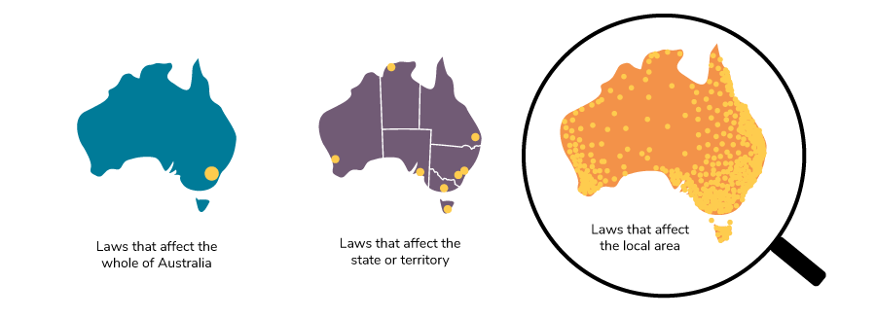
What is the name of your local council/shire/government?

Where is it?

How many people live in this local area?

What are some of the services they look after? Tick the services that you use.

Were there any issues with these services?

What could be done to improve these services?

How can I help make this happen?

