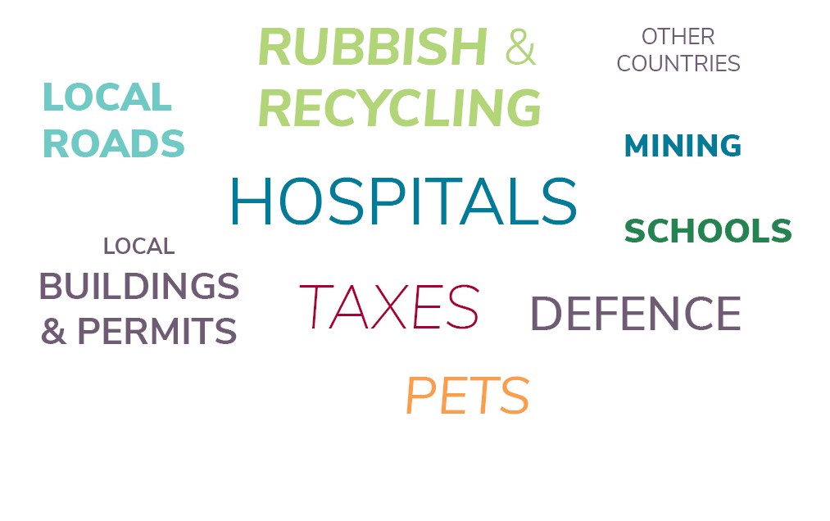
In the word cloud above, circle the areas of local government responsibility and write them below:
____________________________ ____________________________
____________________________ ____________________________

How many local governments are there across Australia? ____________________________

Why did local governments become popular in the 1970s? _____________________________
____________________________________________________________________________
_________________________________________________________________________

Do local governments have more power than state government? Yes / No

Do local governments have more power than the federal government? Yes / No

