Scoring instructions
Decide which difficulty level your group will attempt. If you finish early, move on to the next level.
Level 1 – (least difficult) – Call ‘Bingo’ after your group has found examples for any 2 horizontal rows.
Level 2 – Call ‘Bingo’ after your group has found examples for one horizontal row and one vertical column.
Level 3 – Call ‘Bingo’ after your group has found examples for any 2 vertical columns.
Level 4 (expert) – Call ‘Bingo’ after your group has found examples for all 17 goals.

Table to record your answers
Before you can cross a goal off your Bingo sheet, you must use this table to record an example of how Australian aid is helping to achieve the goal in a Pacific or Southeast Asian nation.

Goal 4 – Quality Education – has already been done for you.

To find examples, investigate the Development Cooperation Factsheets on the DFAT website. Select a nation to read about the impact Australian aid is making on that country. The Program highlights section will help your group to complete the table.
GOAL | COUNTRY | RESULT ACHIEVED WITH AUSTRALIAN AID
1
2
3
4 | Papua New Guinea | Over 3,200 teachers trained in literacy, maths and school management
5
6
7
8
9
10
11
12
13
14
15
16
17

Cross out a goal when you have added it to your table.  See the scoring instructions for when you can call “Bingo”. |  | 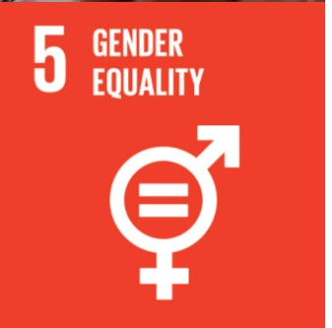
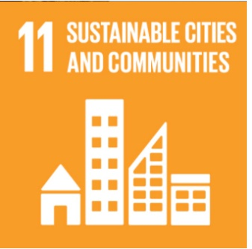 | 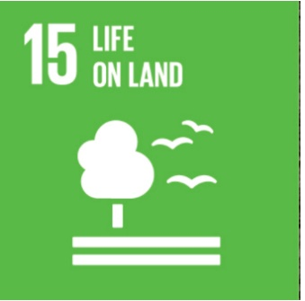 | 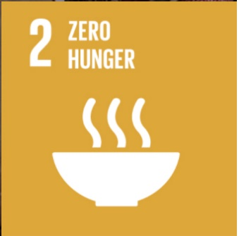
 |  | 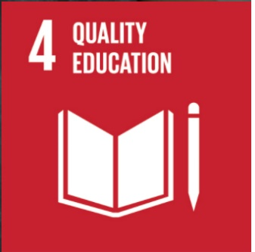
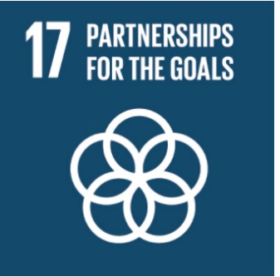 | 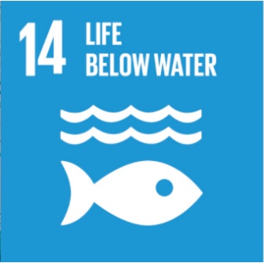 | 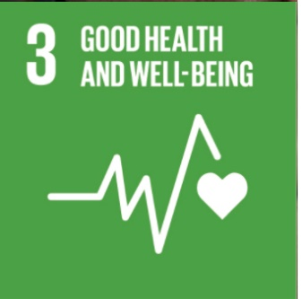
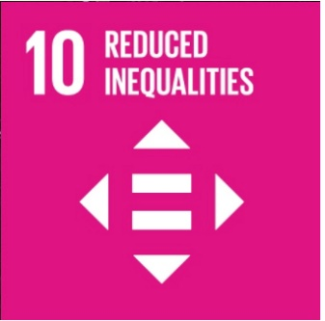 |  | 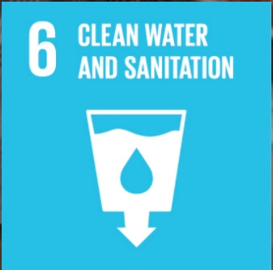
 | 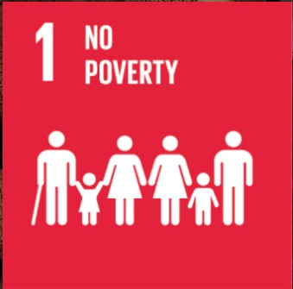 | 