Label and provide a short summary of the 5 different parts of the Australian system of government.
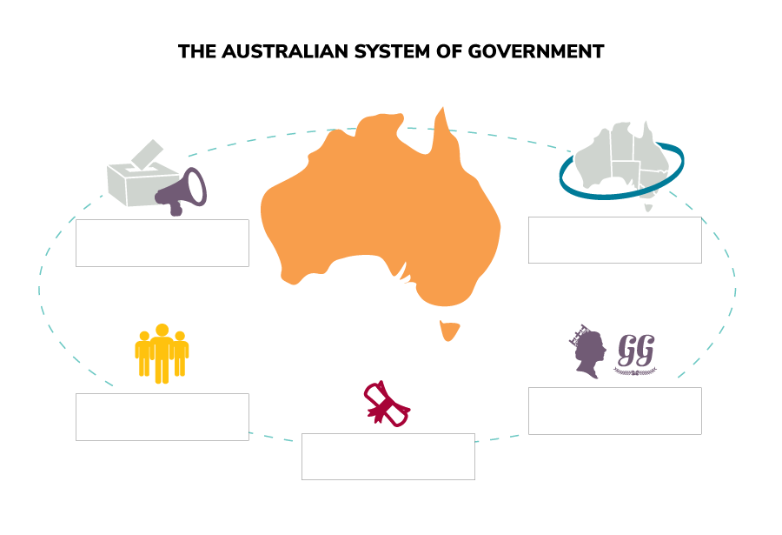
Constitution:

Democracy:

Representative democracy:

Federation of states:

Constitutional monarchy:

