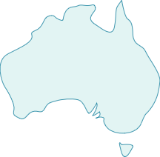

Who are the traditional owners?

Why is the site sacred?

What happens here?

What is the sacred site called?

Where is it located?

How old is it?

What is it made from?

What does it look like?

Other interesting facts