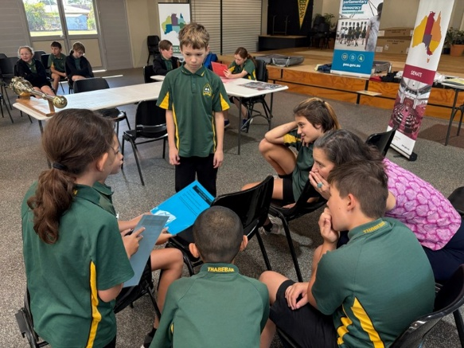
Classroom rules
- Write up to 5 classroom rules.
- Write down a reason for each rule on a separate sticky note.


Playground rules
- Write up to 5 playground rules.
- Write down a reason for each rule on a separate sticky note


Assembly/hall rules
- Write up to 5 assembly/hall rules.
- Write down a reason for each rule on a separate sticky note.


Library rules
- Write down up to 5 library rules.
- Write down a reason for each rule on a separate sticky note.


Canteen rules
- Write down up to 5 canteen rules.
- Write down a reason for each rule on a separate sticky note.

