Did you know?
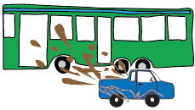
In NSW, you can be fined up to $2, 200 if you splash mud on bus passengers when you’re driving your car.

In NT, you can be fined $200 if you are a musician or busker who ‘play musical instruments so as to annoy’.
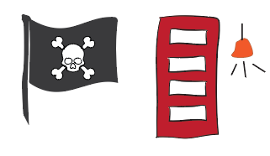
In Victoria it is illegal to do business with pirates. If you do, you could go to prison for up to 10 years!

In TAS, taking or possessing a meteorite is worth a fine of nearly $1600.

In WA Police also have the power to stop and search a vehicle suspected of carrying more than 50kg of potatoes.
In SA you could be fined up to $250 if you ring someone’s doorbell without good reason!
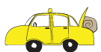
In QLD, taxis must carry a bale of hale in the boot.

