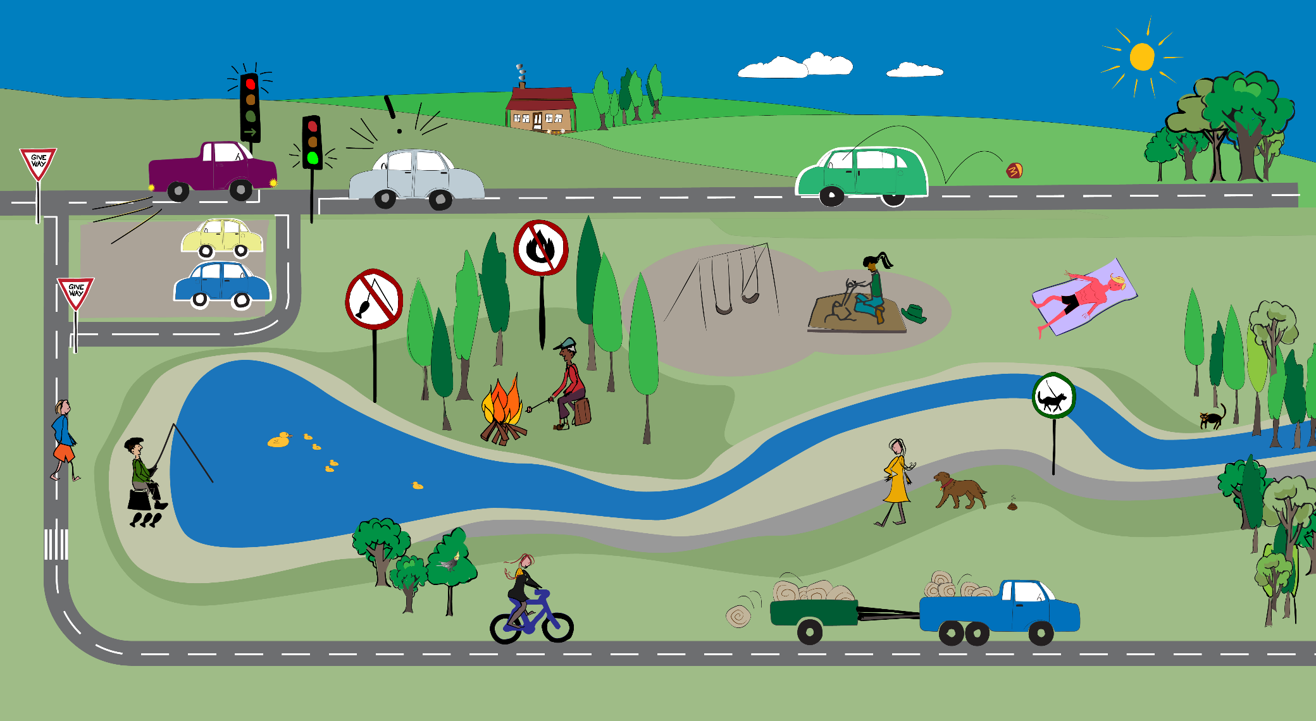
Identify 3 laws: |  | Identify 3 rules:

