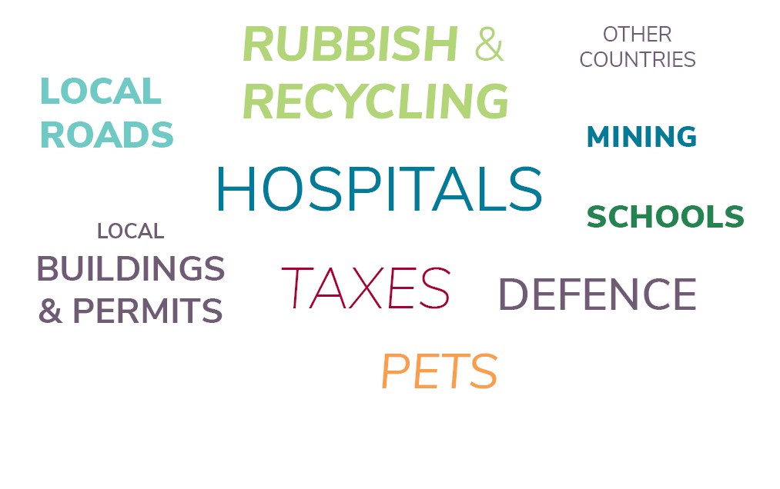
- In the word cloud above, circle the areas that local government is responsible for and write them below:
____________________________ ____________________________
____________________________ ____________________________
- How many local governments are there across Australia? ____________________________
- Why did local governments become popular in the 1970s? _____________________________
____________________________________________________________________________
_________________________________________________________________________

- Do local governments have more power than state government? Yes / No
- Do local governments have more power than the federal government? Yes / No

